

Automation Technology 1

Lab 2: Basic Ladder Logic Design with Counters
Lecturer: Eoin Byrne
Date: 7th October 2026
Name: David Tapia Caicedo

Section 1 – Introduction to Simple Ladder Diagrams

Abstract:
The aim of this section is to familiarise students with basic timer and counter functions alongside operations and the programming of a simple ladder diagrams. Students will download their programs to the Mitsubishi FX3G PLC, test, and verify their programs to ensure satisfactory operation.

Objective:
To gain practical experience constructing ladder diagrams and programming a PLC using timers and counters for outputs for various Scenarios.

Automation Problem 1:

Using GX Works 2 design a ladder Logic program to turn on a Lamp on a Traffic light Station (Y0) when the Start Button(X0) is pressed five times.
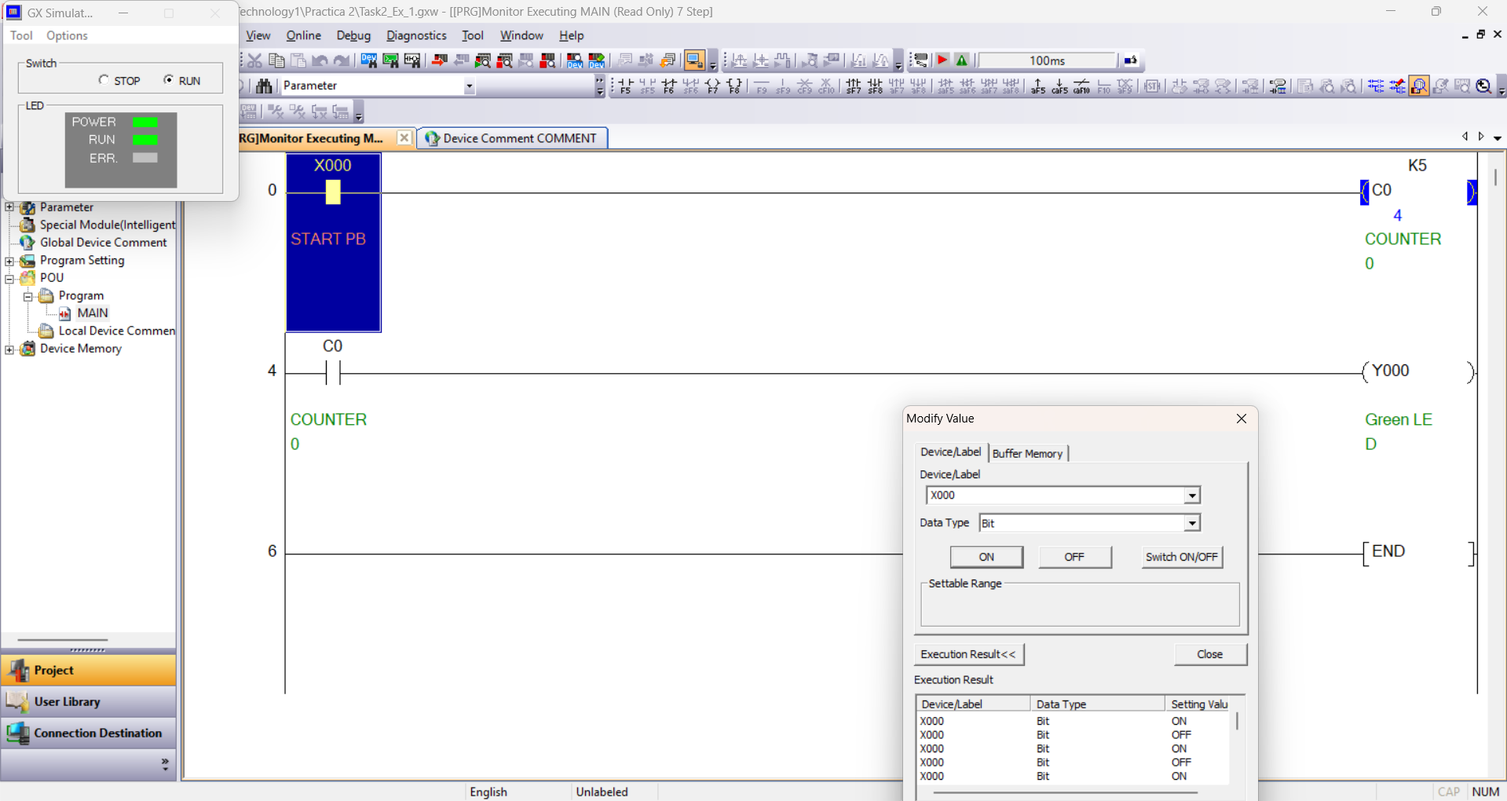
Figure 1: Circuit before reaching 5 counts
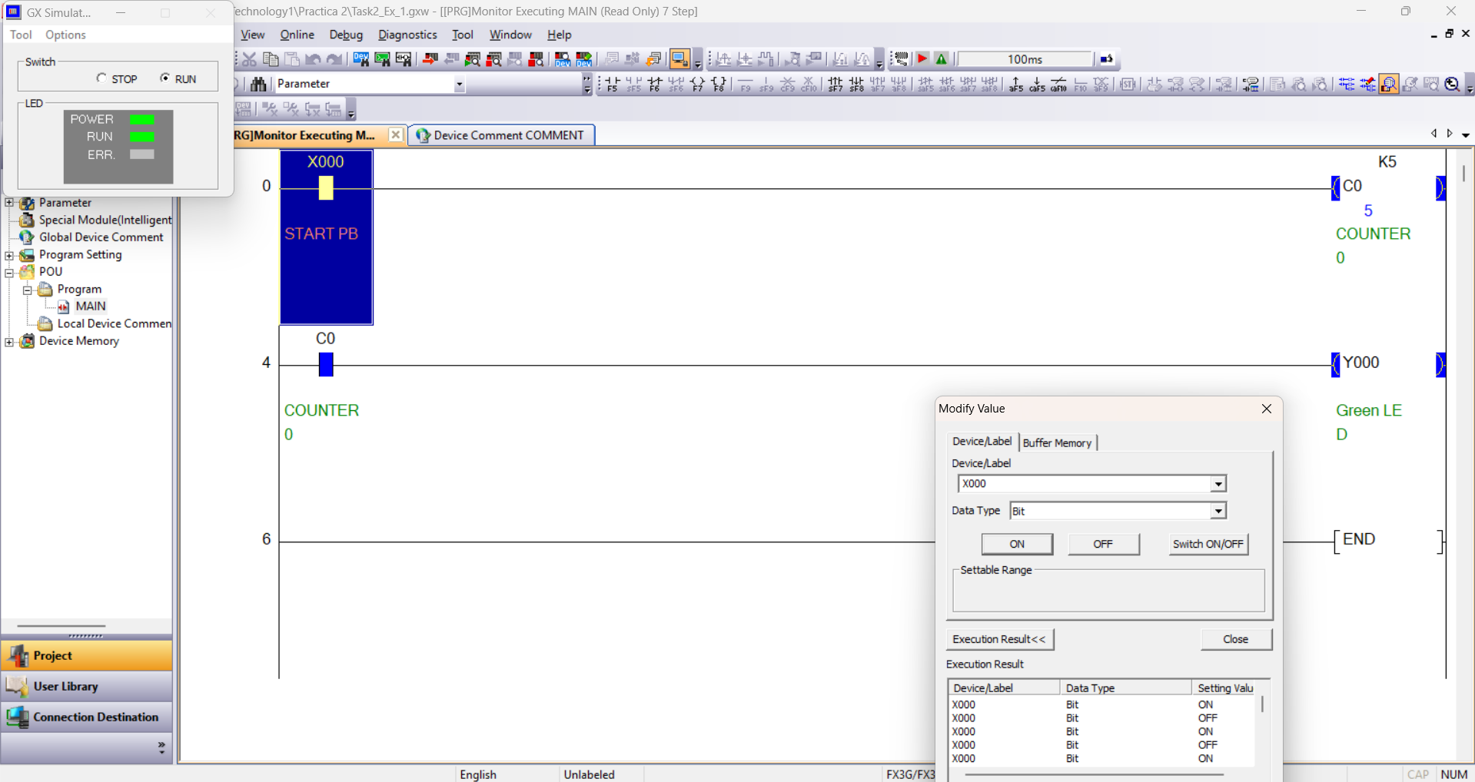
Figure 2: Circuit when C0 reaches 5 counts

Rung 1: Input X0 (Start pushbutton) uses a Normally Open (NO) contact connected to counter C0, which has a preset value of K5. Every time X0 is pressed and switches from OFF to ON, the counter value increases by 1.

Rung 2: A Normally Open contact of C0 is linked to the output coil Y0 (Green LED). When the button X0 is pressed five times, C0 reaches its target value of 5. This closes the C0 contact in the second rung and turns on the lamp Y0.

Automation Problem 2:

Design a PLC Program to meet the following System Requirements
- Create a counter that counts the number of times X0 has been Pressed
- When X0 has been pressed four times, Green on Traffic Station should Luminate.
- When X1 is pressed, the counter should reset an Lamp Y0 should Turn off
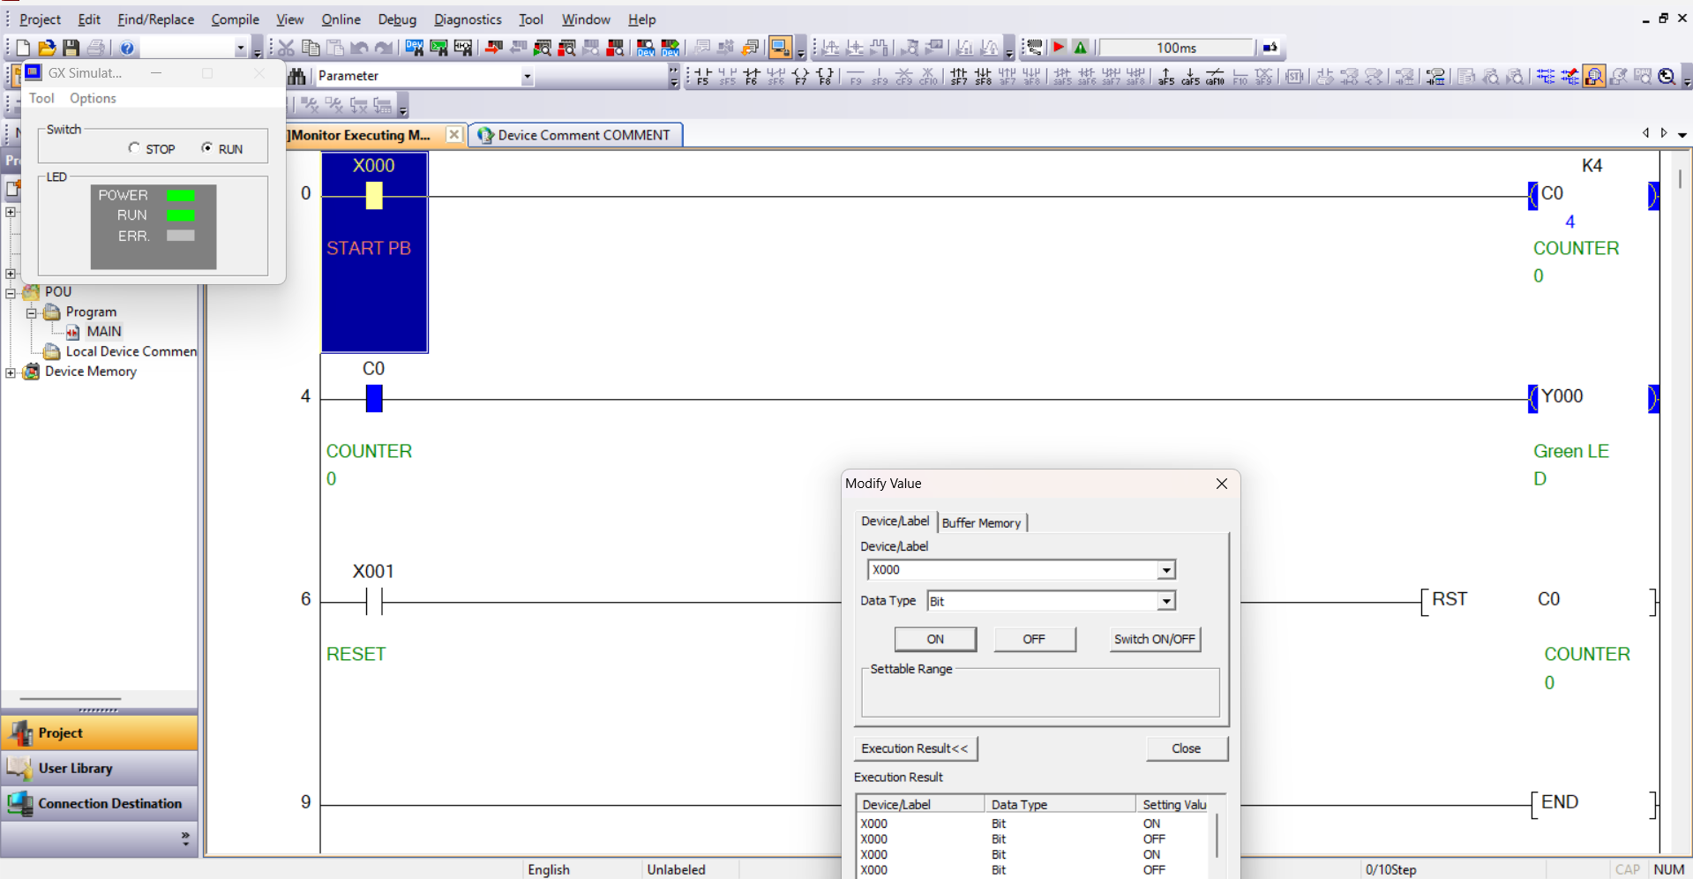
Figure 3: Green lamp on when C0 has 4 counts

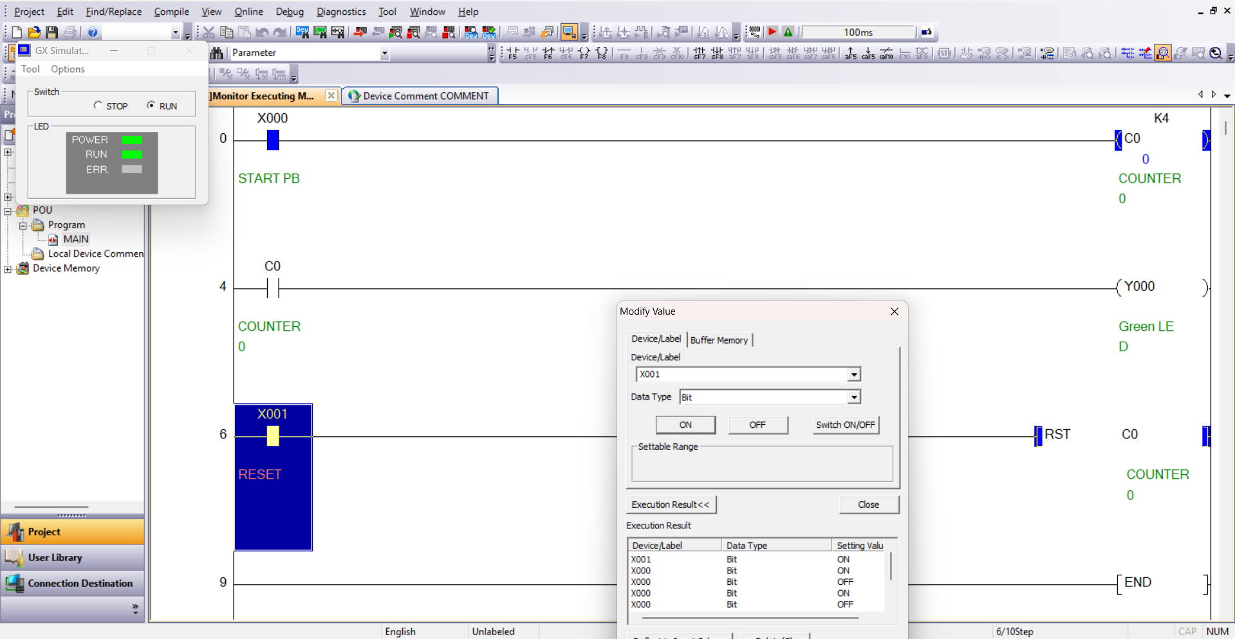
Figure 4: Reset button resets C0 count to 0
Rung 1: The Normally Open contact X0 is connected to counter C0 with a preset limit of K4. Each press on pushbutton X0 adds one count to C0.
Rung 2: When X0 has been pressed four times, counter C0 reaches K4 and closes its NO contact on this rung, which energizes the green lamp output Y0.
Rung 3: Pushbutton X1 is set as a Normally Open contact connected to the [RST C0] instruction. Pressing X1 activates the reset command, returning the C0 counter value back to 0 and opening the C0 contact in Rung 2 so that lamp Y0 turns off.

Automation Problem 3:

Design a PLC Program to meet the following System Requirements
- Lamp Y0 turns on are X0 is pressed five times and tuns off again after an additional five presses of X0
- The Process can be Constantly repeated.

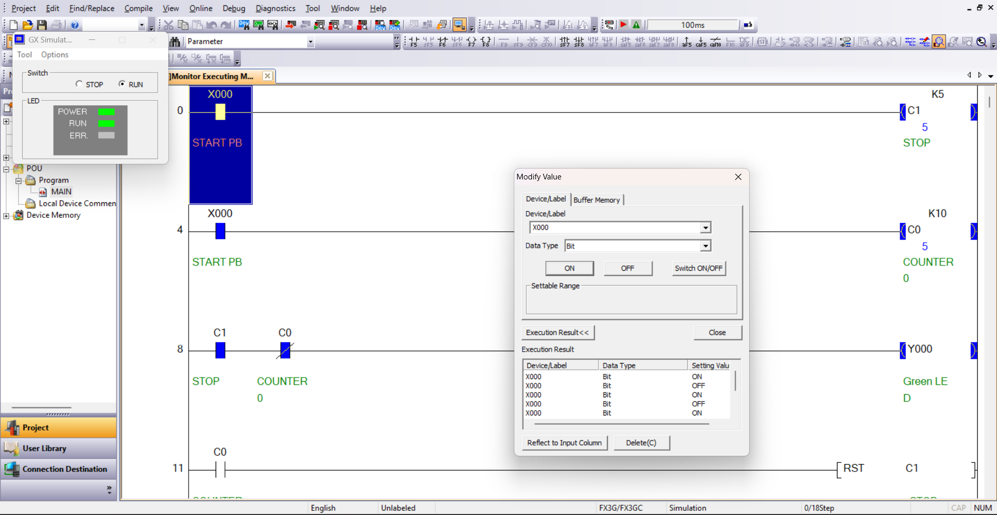
Figure 5: Lamp Y0 on when X0 is pressed 5 times
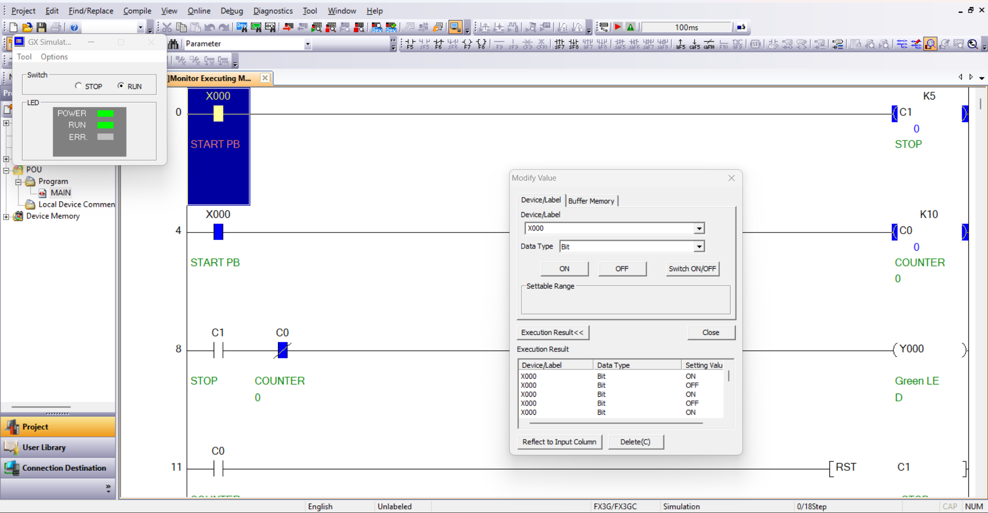
Figure 6: Lamp Y0 is off when X0 is pressed 10 times
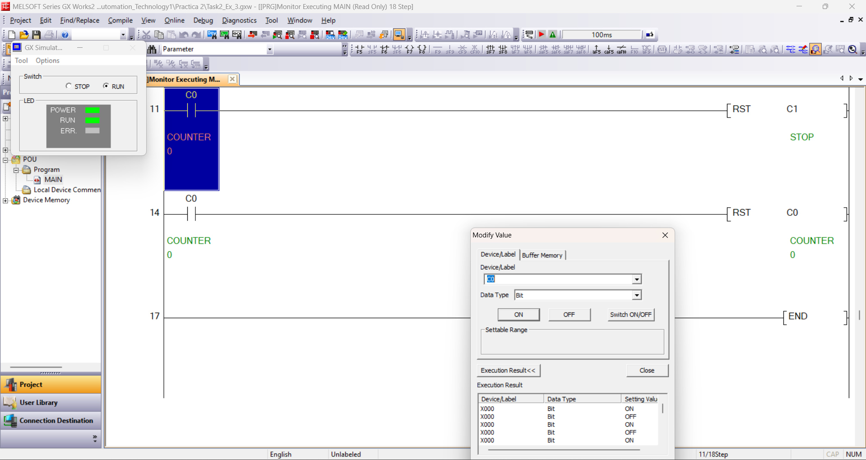
Figure 7: Reset counter
Rungs 1 and 2: In this program, pushbutton X0 controls two counters at the same time. In the first rung, X0 is connected to counter C1 with a preset of K5 (used to turn the lamp on). In the second rung, X0 is connected to counter C0 with a preset of K10 (used to turn the lamp off after five more presses).
Rung 3: The output Y0 is controlled by a Normally Open contact of C1 in series with a Normally Closed (NC) contact of C0. Once X0 is pressed 5 times, C1 activates and closes its contact, turning lamp Y0 on while C0 is still below 10. The lamp stays on during presses 6, 7, 8, and 9.
Rungs 4 and 5: On the 10th press of X0, counter C0 reaches K10. Its NC contact in Rung 3 opens to switch Y0 off, while its NO contacts in Rungs 4 and 5 trigger [RST C1] and [RST C0]. Both counters go back to zero automatically, so the whole cycle can be repeated again.

Automation Problem 4:

Design a PLC Program to meet the following System Requirements

- When X0 is pressed four times followed by five presses of X1, output lamp Y0 should energize.
- The lamp mustn’t turn on if either X0 or X1 are pressed 9 times.
- When both X0 and X1 are pressed the counter should reset
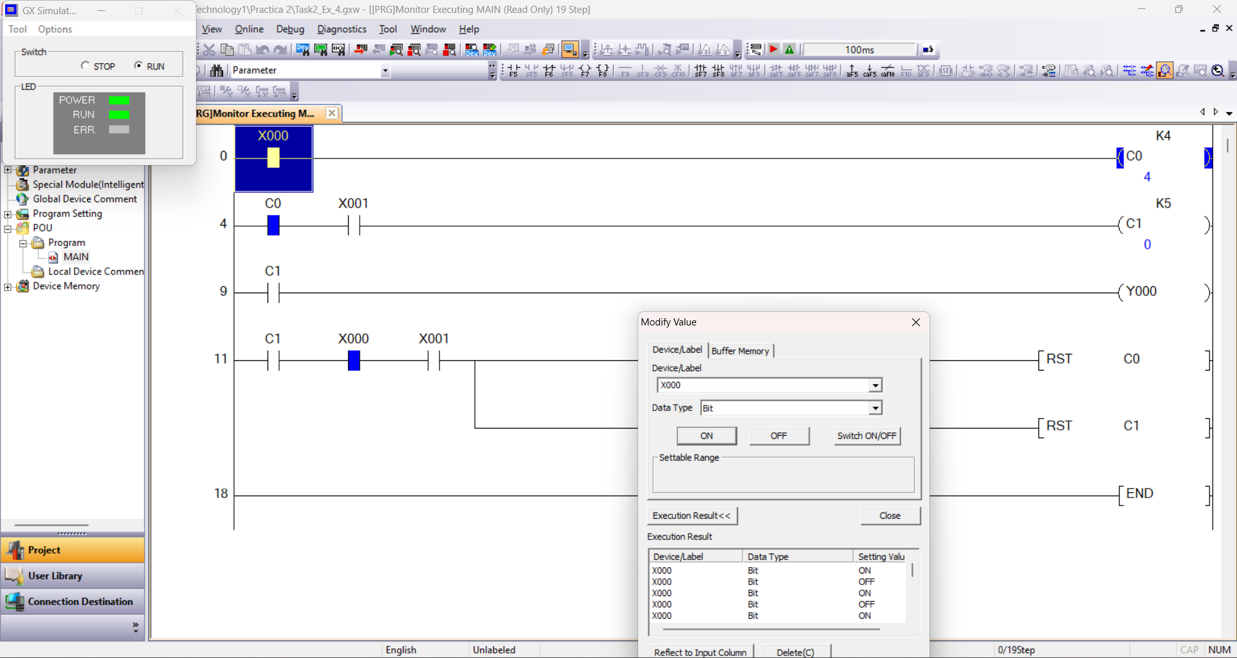
Figure 8: X0 pressed 4 times
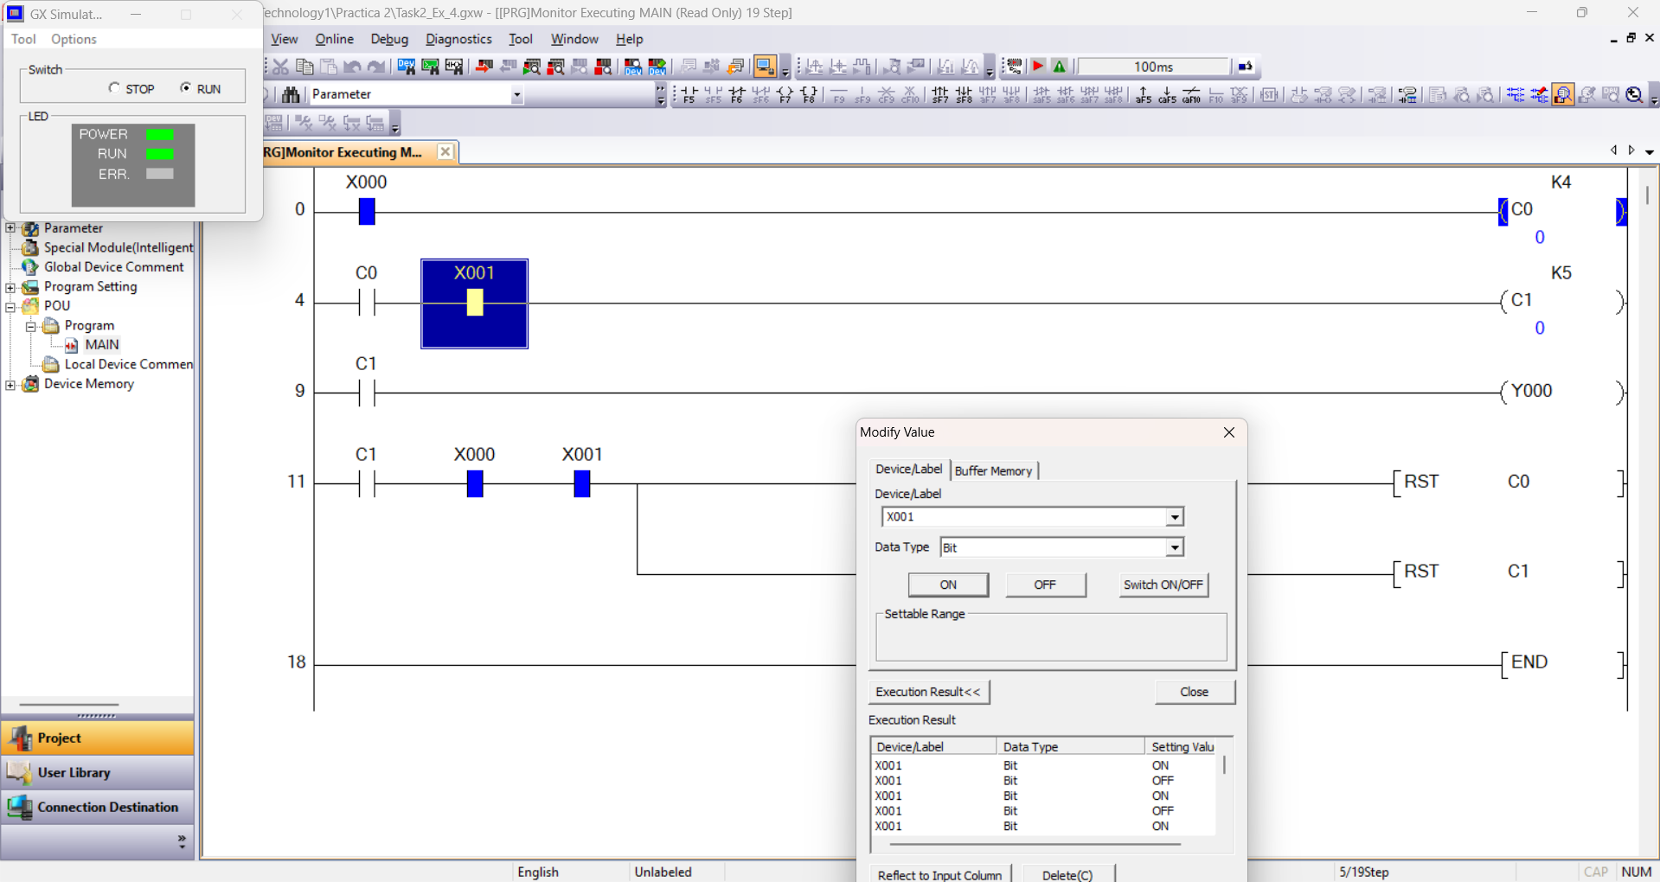
Figure 9: When X1 is pressed 5 times Y0 is energized and reset counters
Rung 1: Pushbutton X0 is connected to counter C0 with a preset of K4. Since X0 only goes to C0, pressing X0 nine times by itself will only activate C0 and will not turn on the lamp.
Rung 2: To make sure X1 is only counted after X0 has been pressed 4 times, a Normally Open contact of C0 is placed in series before X1 to feed counter C1 (K5). Because of this interlock, pressing X1 before C0 reaches 4 does nothing, so pressing X1 nine times on its own cannot turn on the output either.
Rung 3: Once C0 reaches 4 and X1 is then pressed 5 times, counter C1 reaches K5. This closes the C1 Normally Open contact in Rung 3 and turns on output lamp Y0.
Rung 4: Once the sequence is completed (C1 active), pressing both X0 and X1 at the same time closes the series NO contacts on this rung and triggers the parallel [RST C0] and [RST C1] instructions. This resets both counters back to 0 and turns off Y0.

Automation Problem 5:

Design a PLC Program to meet the following System Requirements
- When the PLC is turned on there should be no lights on traffic light station
- When X0 is pressed Y0 should energize
- When X0 is pressed again the next lamp should turn on (Y1)
- When X0 is pressed again the next lamp should turn on (Y2)
- When X0 is pressed again the next lamp should turn on (Y3)
- Finally when pressed again all traffic lights should be off and the process should be able to start again
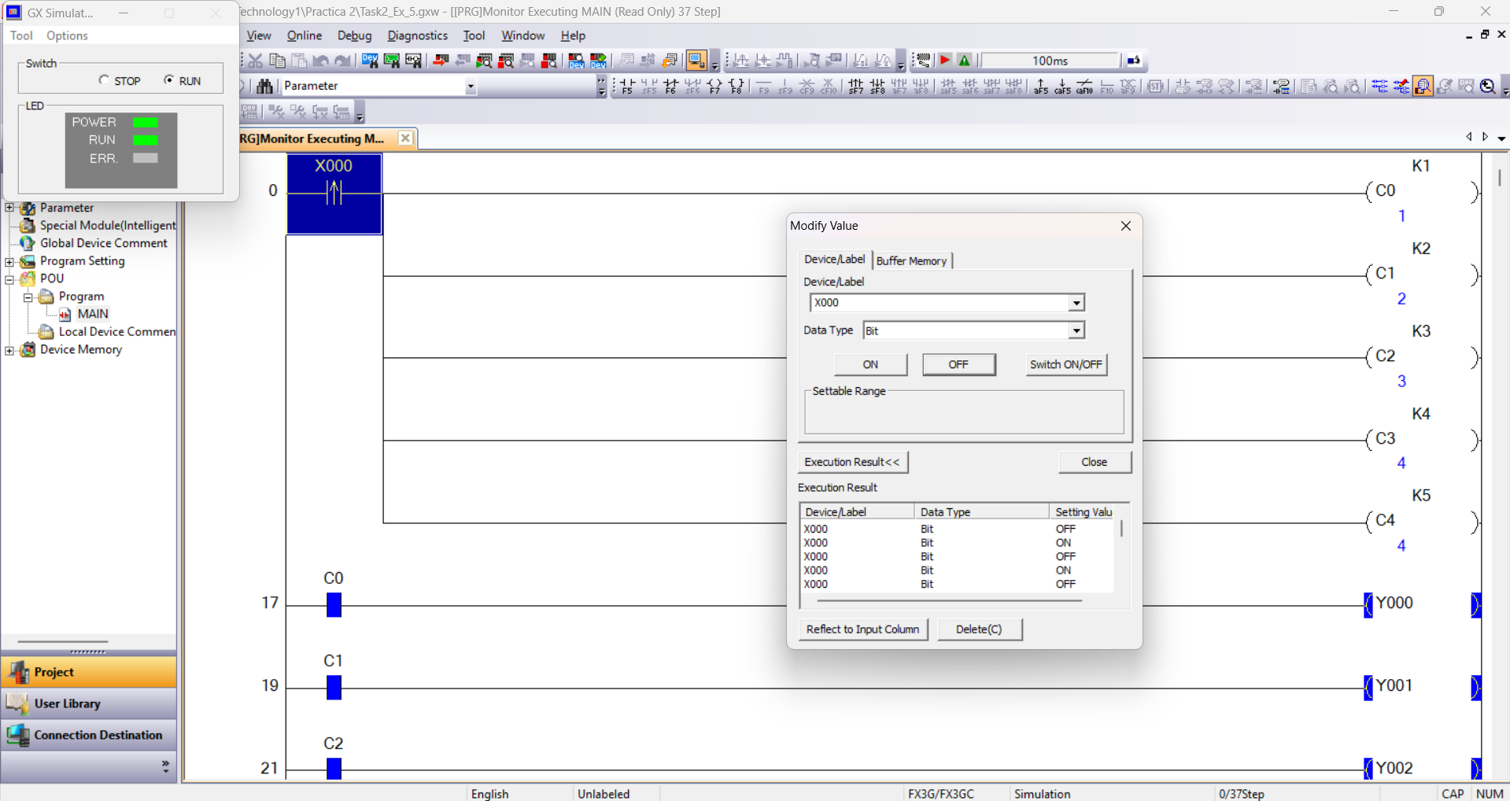
Figure 10: X0 pressed 4 times and lamps energized
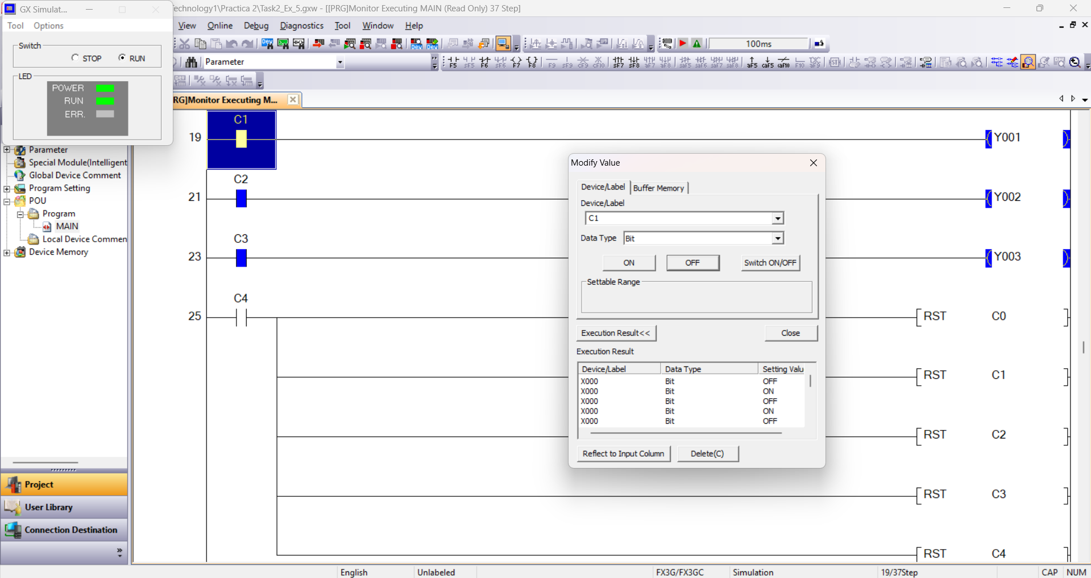
Figure 11: Y0 to Y3 lamps energized
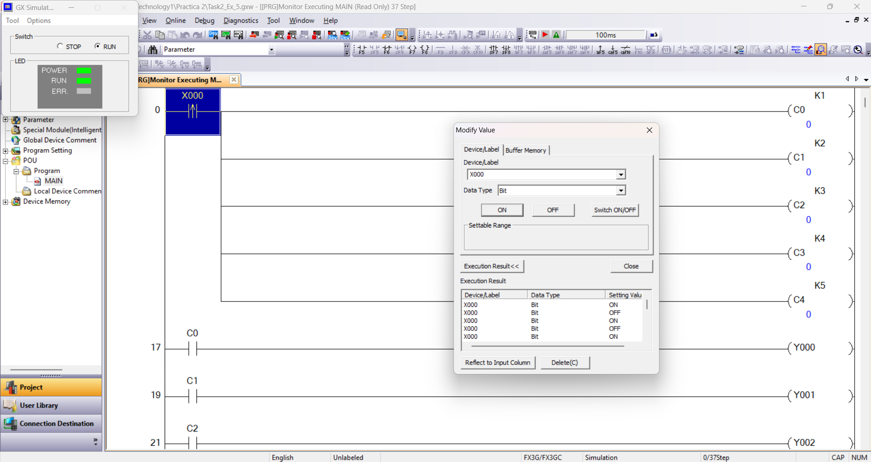
Figure 12: X0 pressed 5 times and reset every lamp
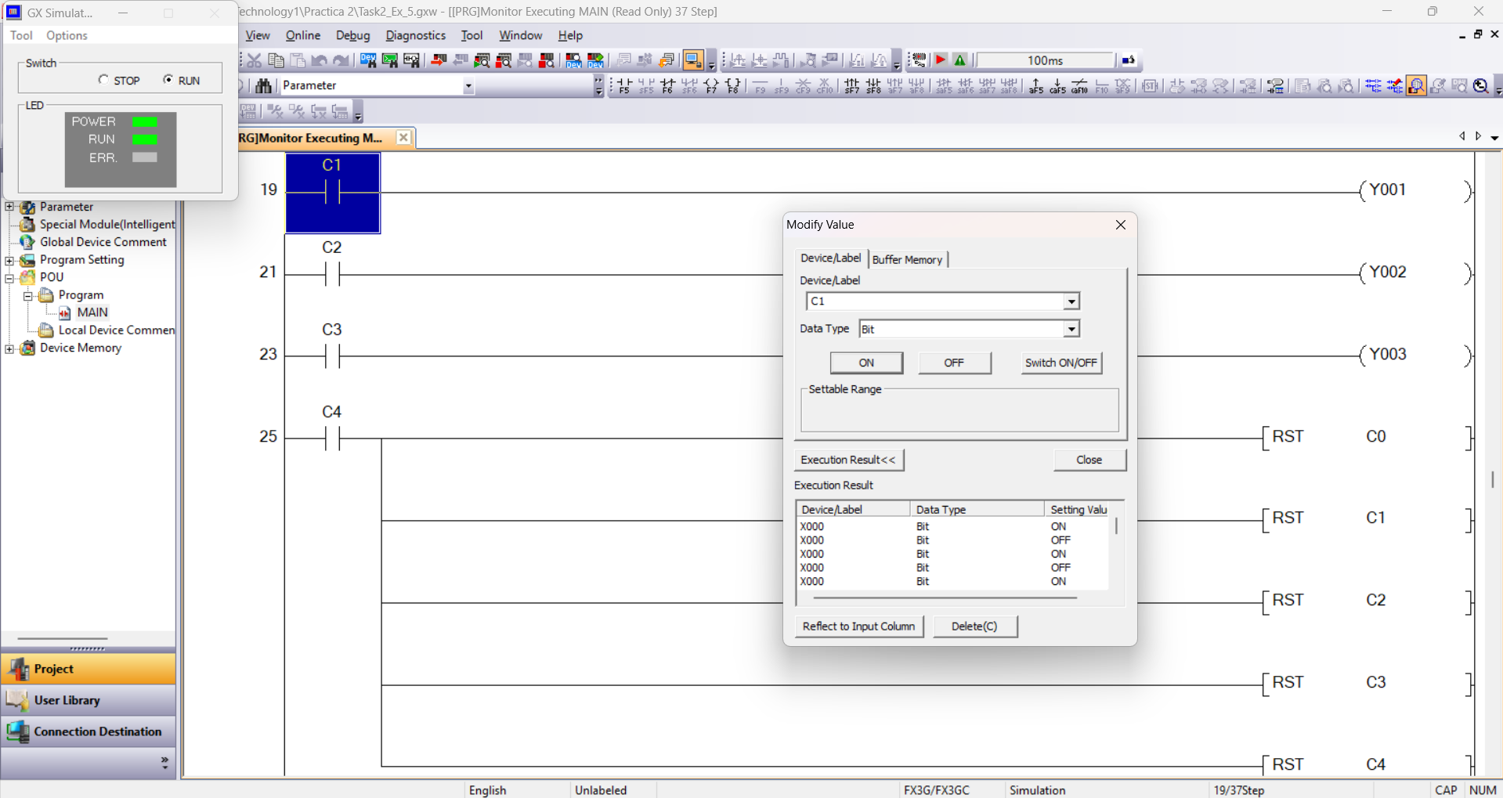
Figure 13: Y0 to Y3 lamps reset
Initial State: When the PLC is turned on, all five counters (C0 to C4) start at zero, so all traffic light outputs (Y0, Y1, Y2, and Y3) are off.
Rung 1 (Parallel Counters): Input X0 is configured as a rising-edge pulse contact connected to five parallel branches for counters C0 (K1), C1 (K2), C2 (K3), C3 (K4), and C4 (K5). Each press of X0 sends a single pulse to all five counters at the same time.
Rungs 2 to 5 (Lamp Outputs):
- On the 1st press of X0, C0 reaches K1 and closes its NO contact to turn on lamp Y0.
- On the 2nd press, C1 reaches K2 and turns on the next lamp, Y1.
- On the 3rd press, C2 reaches K3 and turns on lamp Y2.
- On the 4th press, C3 reaches K4 and turns on lamp Y3.
Rung 6 (Cycle Reset): On the 5th press of X0, counter C4 reaches K5 and closes its NO contact. This triggers all five reset instructions ([RST C0] to [RST C4]) in parallel, turning off all the lights (Y0 to Y3) and resetting the counters to zero so the sequence can start again.

Lab Conclusion & Practical Industrial Example
During this lab practical, we gained hands-on experience designing and testing counter-based Ladder Logic programs for the Mitsubishi FX3G PLC using GX Works2. Throughout the five exercises, counters were combined with Normally Open (NO), Normally Closed (NC), and rising-edge pulse contacts, as well as [RST] instructions to control different traffic light sequences. Each program was first tested in the GX Works2 simulator to verify that the counting logic and reset conditions worked properly before downloading the code to the physical PLC test rig. Working through Problems 3, 4, and 5 also showed how combining multiple counters allows a PLC to either run a sequence in a strict order or reset itself automatically to repeat a cycle continuously.
A practical example could be a car park system with a traffic light station. When a car approaches the car park entrance, the driver will see a traffic light with three possible lights: green indicates that space is available, amber indicates that the car park is near 90% capacity, and red means that it is full. Every time a car passes through, a counter increments by one to keep track of how much space remains in the car park.
At the end of the shift, the operator resets the system and the traffic light by pressing a reset button.

